Decision (Branch) Testing & Coverage

What is Decision Testing
# Source: AI Source: Provided by: [Data Path: Persons Table -> ID Column: 1, Name_En Column: Motasem Essam] -> From: [ChatGPT] on [8/24/2025]
Decision Testing (also called Branch Testing) is a white-box testing technique that ensures each decision point (like if, switch, loops, etc.) in the code takes all possible outcomes (True/False) at least once.
Decision (Branch) Coverage is the metric that measures how many decision outcomes have been tested versus how many exist.

📊 Formula for Decision Coverage:
# Source: AI Source: Provided by: [Data Path: Persons Table -> ID Column: 1, Name_En Column: Motasem Essam] -> From: [ChatGPT] on [8/24/2025]
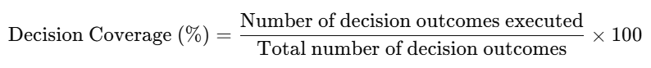
Decision Coverage (%)=Number of decision outcomes executedTotal number of decision outcomes×100\text{Decision Coverage (\%)} = \frac{\text{Number of decision outcomes executed}}{\text{Total number of decision outcomes}} \times 100

🔍 Example:
# Source: AI Source: Provided by: [Data Path: Persons Table -> ID Column: 1, Name_En Column: Motasem Essam] -> From: [ChatGPT] on [8/24/2025]
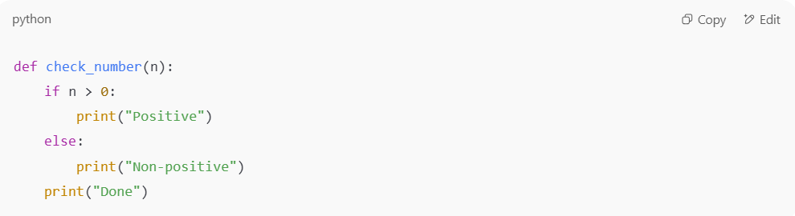
def check_number(n):
if n > 0:
print("Positive")
else:
print("Non-positive")
print("Done")

- Decisions:
  - if n > 0 has 2 outcomes → True and False.
- Test Case 1: n = 5
  - Executes branch → True (print("Positive"))
  - Coverage = 1 of 2 outcomes = 50%
- Test Case 2: n = -3
  - Executes branch → False (print("Non-positive"))
  - Coverage = both outcomes tested = 100%

✅ Why is it stronger than Statement Coverage?
# Source: AI Source: Provided by: [Data Path: Persons Table -> ID Column: 1, Name_En Column: Motasem Essam] -> From: [ChatGPT] on [8/24/2025]
- Statement Coverage only checks if all lines are executed.
- Decision Coverage checks if all logic outcomes (True/False paths) are tested.
👉 Example where statement coverage is 100% but decision coverage is
50%:
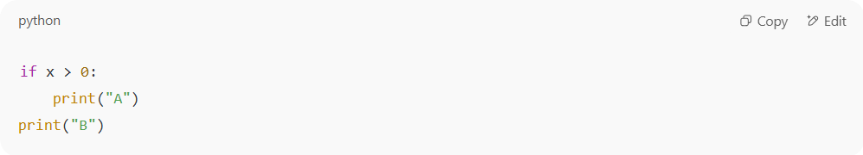
if x > 0:
print("A")
print("B")

- Test Case: x = 5 → runs both statements (print("A") and print("B")) → 100% statement coverage.
- But only the True branch was tested. The False branch (x <= 0) was never tested → 50% decision coverage.

⚖️ Advantages:
# Source: AI Source: Provided by: [Data Path: Persons Table -> ID Column: 1, Name_En Column: Motasem Essam] -> From: [ChatGPT] on [8/24/2025]
- Ensures all decision outcomes are tested.
- Catches more logic errors than statement testing.

⚠️ Limitations:
# Source: AI Source: Provided by: [Data Path: Persons Table -> ID Column: 1, Name_En Column: Motasem Essam] -> From: [ChatGPT] on [8/24/2025]
- Does not cover all combinations of conditions inside complex decisions (that’s for Condition Coverage or Multiple Condition Coverage).

✅ In short:
Decision (Branch) Testing = making sure every True/False outcome of decisions is tested.
Decision Coverage = how many of those outcomes were actually executed during testing.

Control Flow Graph (CFG)

What is Control Flow Graph (CFG)
# Source: AI Source: Provided by: [Data Path: Persons Table -> ID Column: 1, Name_En Column: Motasem Essam] -> From: [ChatGPT] on [8/24/2025]
A Control Flow Graph (CFG) is a graphical representation of a program’s control structure, showing all possible paths that execution can take through the code.

📌 Key Elements
# Source: AI Source: Provided by: [Data Path: Persons Table -> ID Column: 1, Name_En Column: Motasem Essam] -> From: [ChatGPT] on [8/24/2025]
- Nodes → Represent program statements or blocks of code (e.g., assignments, function calls).
- Edges → Represent control flow (the direction the program execution can take, e.g., after an if condition or loop).
- Entry node → Starting point of execution.
- Exit node → End of execution.

📊 Example
# Source: AI Source: Provided by: [Data Path: Persons Table -> ID Column: 1, Name_En Column: Motasem Essam] -> From: [ChatGPT] on [8/24/2025]
Code snippet:
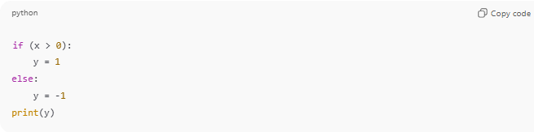
if (x > 0):
y = 1
else:
y = -1
print(y)
CFG Representation:
- Node 1: if (x > 0)
- Node 2: y = 1 (true branch)
- Node 3: y = -1 (false branch)
- Node 4: print(y)
Edges:
- 1 → 2 → 4
- 1 → 3 → 4

🔹 Why It’s Useful
# Source: AI Source: Provided by: [Data Path: Persons Table -> ID Column: 1, Name_En Column: Motasem Essam] -> From: [ChatGPT] on [8/24/2025]
- Helps visualize program logic.
- Used in white-box testing (especially statement testing, branch testing, and path testing).
- Supports coverage analysis by showing which paths/statements are tested.

👉 In short: a control flow graph is the map of execution paths in a program, used to guide systematic test design.

CFG links directly to statement coverage and branch coverage
# Source: AI Source: Provided by: [Data Path: Persons Table -> ID Column: 1, Name_En Column: Motasem Essam] -> From: [ChatGPT] on [8/24/2025]
Let’s walk through an example step by step so you see how Control Flow Graph (CFG) connects with Statement Coverage and Branch Coverage.

🔹 Example Code
# Source: AI Source: Provided by: [Data Path: Persons Table -> ID Column: 1, Name_En Column: Motasem Essam] -> From: [ChatGPT] on [8/24/2025]
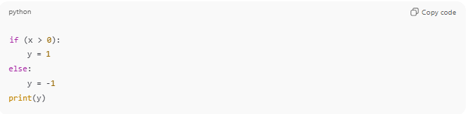
if (x > 0):
y = 1
else:
y = -1
print(y)

🔹 Step 1: Build the Control Flow Graph (CFG)
- Node 1: if (x > 0)
- Node 2: y = 1 (true branch)
- Node 3: y = -1 (false branch)
- Node 4: print(y)
Edges:
- 1 → 2 → 4
- 1 → 3 → 4

🔹 Step 2: Statement Coverage
Goal: Execute all statements at least once.
- Test Case A: x = 5 → Path: 1 → 2 → 4 → Executes Node 1, 2, 4
- But Node 3 is missed.
Coverage = 3/4 = 75%
To reach 100%, add another test:
- Test Case B: x = -5 → Path: 1 → 3 → 4 → Executes Node 1, 3, 4
Now all statements (1, 2, 3, 4) are covered.
Coverage = 4/4 = 100% ✅

🔹 Step 3: Branch Coverage
Goal: Execute all edges (true/false outcomes of decisions).
- From Node 1 (if x > 0) → two branches:
  - True branch → Node 2
  - False branch → Node 3
Test Case A: x = 5 → covers true branch
Test Case B: x = -5 → covers false branch
Both branches covered = 100% branch coverage ✅

🔹 Key Insight
- Statement coverage checks nodes → “Did I run every statement at least once?”
- Branch coverage checks edges → “Did I take every possible decision outcome at least once?”
- CFG is the map that lets you measure both systematically.

